Day 17- 12th July- 113195064 - Bondili Bhavya Charitha

TASK:1&2 – AVL Algorithm
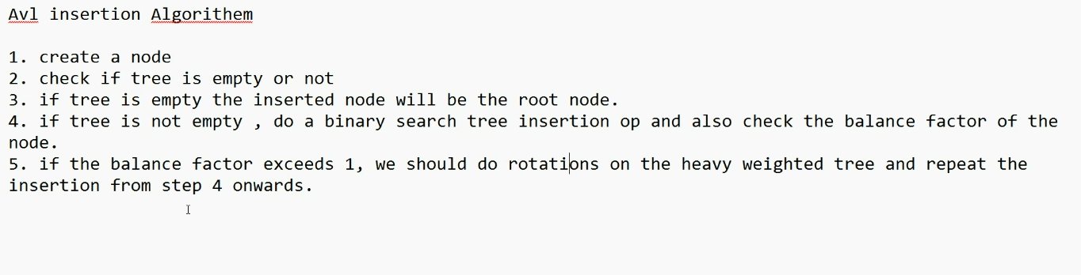

Code:
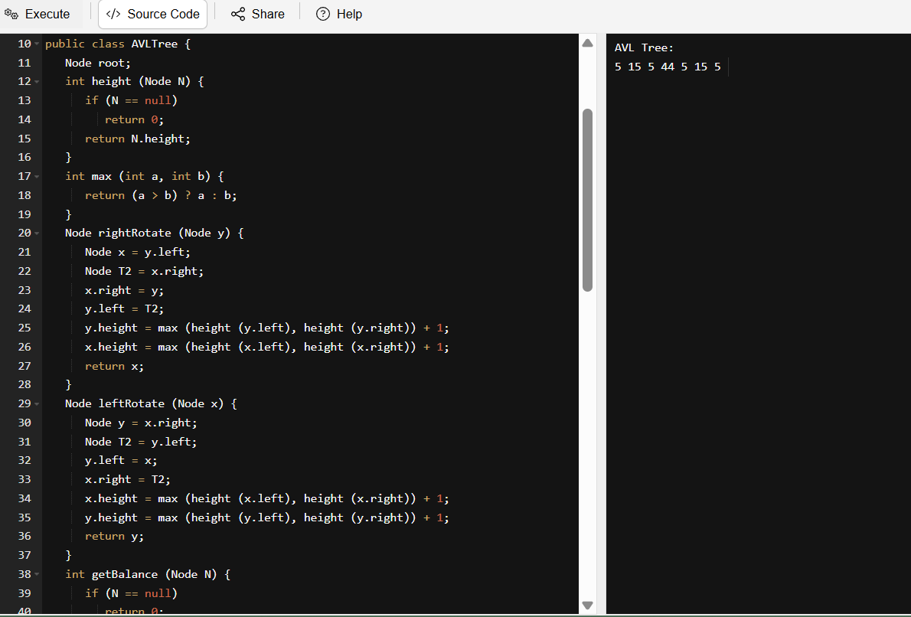
import java.util.*;
class Node {
int key, height;
Node left, right;
Node (int d) {
key = d;
height = 1;
}
}
public class AVLTree {
Node root;
int height (Node N) {
if (N == null)
return 0;
return N.height;
}
int max (int a, int b) {
return (a > b) ? a : b;
}
Node rightRotate (Node y) {
Node x = y.left;
Node T2 = x.right;
x.right = y;
y.left = T2;
y.height = max (height (y.left), height (y.right)) + 1;
x.height = max (height (x.left), height (x.right)) + 1;
return x;
}
Node leftRotate (Node x) {
Node y = x.right;
Node T2 = y.left;
y.left = x;
x.right = T2;
x.height = max (height (x.left), height (x.right)) + 1;
y.height = max (height (y.left), height (y.right)) + 1;
return y;
}
int getBalance (Node N) {
if (N == null)
return 0;
return height (N.left) - height (N.right);
}
Node insert (Node node, int key) {
if (node == null)
return (new Node (key));
if (key < node.key)
node.left = insert (node.left, key);
else if (key > node.key)
node.right = insert (node.right, key);
else
return node;
node.height = 1 + max (height (node.left), height (node.right));
int balance = getBalance (node);
if (balance > 1 && key < node.left.key)
return rightRotate (node);
if (balance < -1 && key > node.right.key)
return leftRotate (node);
if (balance > 1 && key > node.left.key) {
node.left = leftRotate (node.left);
return rightRotate (node);
}
if (balance < -1 && key < node.right.key) {
node.right = rightRotate (node.right);
return leftRotate (node);
}
return node;
}
void printTree(Node root){
if (root == null)
return;
if (root != null) {
printTree(root.left);
System.out.print(root.key + " ");
printTree(root.left);
}
}
public static void main(String args[]) {
AVLTree tree = new AVLTree();

tree.root = tree.insert(tree.root, 5);
tree.root = tree.insert(tree.root, 15);
tree.root = tree.insert(tree.root, 44);
tree.root = tree.insert(tree.root, 35);
tree.root = tree.insert(tree.root, 65);
tree.root = tree.insert(tree.root, 78);
System.out.println("AVL Tree: ");
tree.printTree(tree.root);

}
}

TASK:3 – Algorithm for Red Black Tree Insertion
- Insert an Element - Red Black Tree −
- Check tree is empty. If empty, then insert new node - color Black. (Because Root Node - Black in color)
- else if Tree - not empty then insert new node as leaf node to the end and color - Red.
- If parent of new node is Red and its neighbours(parent’s) node is also Red,
then Flip the color of the both neighbour and Parent and Grandparents (If it is not Root Node Otherwise Flip the color of the Parent and neighbour only) i.e., Black.
- If parent of new node is Red and its neighbours(parent’s) node is empty or NULL,
then Rotate (either Left-Left or Left-Right rotation) the new node and parent.
- we have two types of rotation
Left Left Rotation and
Left Right Rotation.
- we apply Rotation in some conditions only.
The conditions are −
- If parent of new node is Red and neighbour node is empty or NULL, then rotate left or right rotation.
- In Left-Left Rotation flip the color of the parent and grandparent.
- Make the parent as Grandparent and grandparent as child

TASK:4 - Wap to insert an element in red black tree.
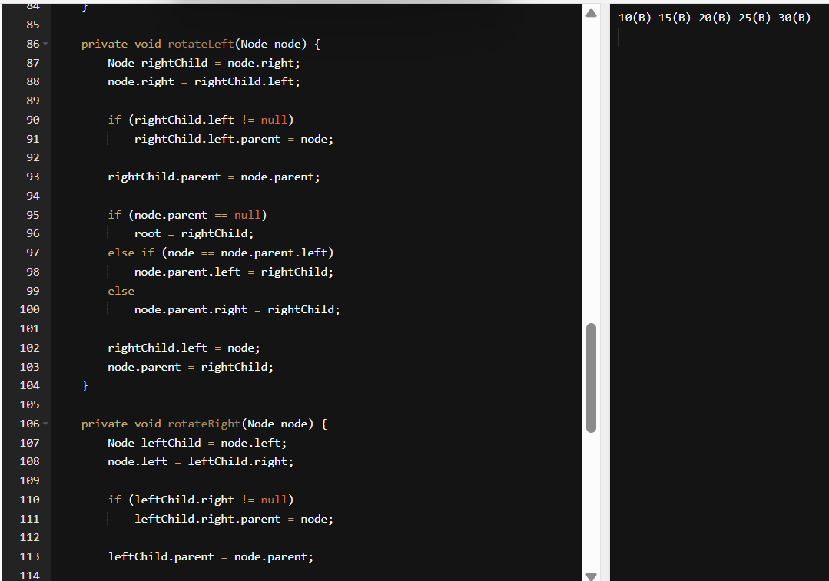
class RedBlackTree {

private static final boolean RED = true;
private static final boolean BLACK = false;

class Node {
int data;
Node left, right, parent;
boolean color;

Node(int data) {
this.data = data;
this.color = RED;
}
}

private Node root;

public void insert(int data) {
Node newNode = new Node(data);
root = insertRecursive(root, newNode);
fixViolation(newNode);
}

private Node insertRecursive(Node current, Node newNode) {
if (current == null) {
newNode.color = BLACK;
return newNode;
}

if (newNode.data < current.data) {
current.left = insertRecursive(current.left, newNode);
current.left.parent = current;
} else {
current.right = insertRecursive(current.right, newNode);
current.right.parent = current;
}

return current;
}

private void fixViolation(Node node) {
while (node != root && node.parent.color == RED) {
Node parent = node.parent;
Node grandparent = parent.parent;

if (parent == grandparent.left) {
Node uncle = grandparent.right;

if (uncle != null && uncle.color == RED) {
parent.color = BLACK;
uncle.color = BLACK;
grandparent.color = RED;
node = grandparent;
} else {
if (node == parent.right) {
node = parent;
rotateLeft(node);
}
parent.color = BLACK;
grandparent.color = RED;
rotateRight(grandparent);
}
} else {
Node uncle = grandparent.left;

if (uncle != null && uncle.color == RED) {
parent.color = BLACK;
uncle.color = BLACK;
grandparent.color = RED;
node = grandparent;
} else {
if (node == parent.left) {
node = parent;
rotateRight(node);
}
parent.color = BLACK;
grandparent.color = RED;
rotateLeft(grandparent);
}
}
}
root.color = BLACK;
}

private void rotateLeft(Node node) {
Node rightChild = node.right;
node.right = rightChild.left;

if (rightChild.left != null)
rightChild.left.parent = node;

rightChild.parent = node.parent;

if (node.parent == null)
root = rightChild;
else if (node == node.parent.left)
node.parent.left = rightChild;
else
node.parent.right = rightChild;

rightChild.left = node;
node.parent = rightChild;
}

private void rotateRight(Node node) {
Node leftChild = node.left;
node.left = leftChild.right;

if (leftChild.right != null)
leftChild.right.parent = node;

leftChild.parent = node.parent;

if (node.parent == null)
root = leftChild;
else if (node == node.parent.left)
node.parent.left = leftChild;
else
node.parent.right = leftChild;

leftChild.right = node;
node.parent = leftChild;
}

public void inorder() {
inorderTraversal(root);
System.out.println();
}

private void inorderTraversal(Node node) {
if (node != null) {
inorderTraversal(node.left);
System.out.print(node.data + "(" + (node.color == RED ? "R" : "B") + ") ");
inorderTraversal(node.right);
}
}
}
public class Main {
public static void main(String[] args) {
RedBlackTree tree = new RedBlackTree();
tree.insert(10);
tree.insert(20);
tree.insert(30);
tree.insert(15);
tree.insert(25);
tree.inorder();
}
}
Later Discussed conducted Quiz answers and posted those answers in Day DOCS.

